**Phet: Waves Intro- Water, Sound and Light**

**Go to** the Phet website and under Physics, **click on** **Waves Intro** and **choose the** **Water** simulation.

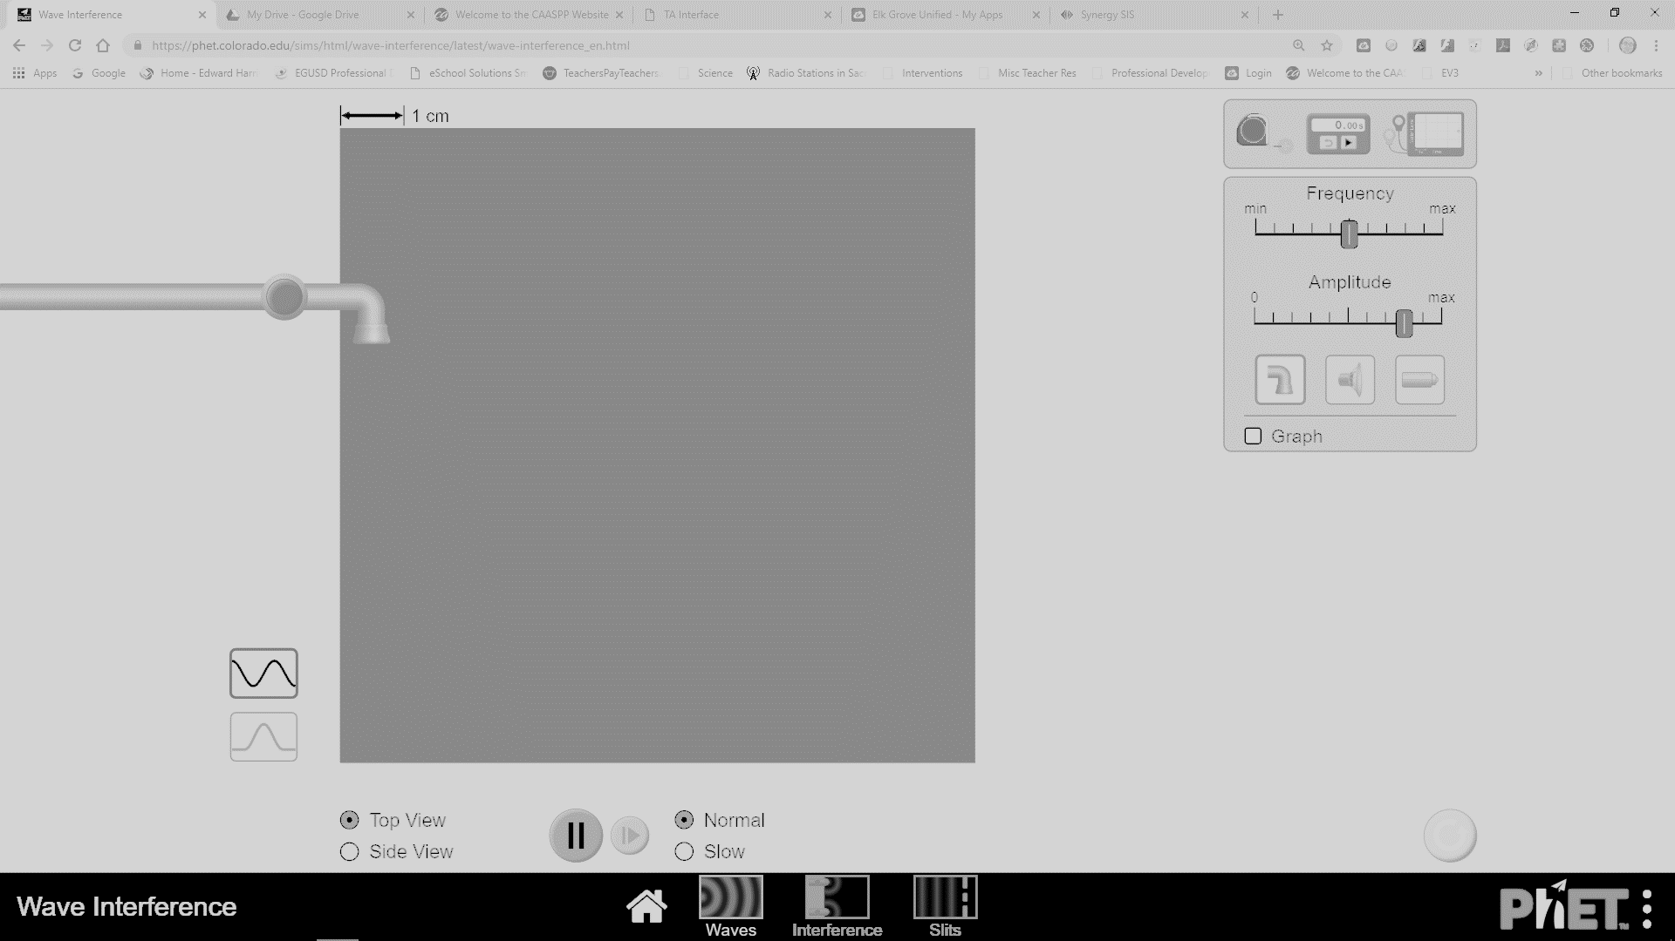

**Click on the green button and turn on the liquid water dropping into a container filled with liquid water (top view).**

1. What does the dropping liquid create?

2. Describe what you see as the liquid continues to drop?

3. Increase and decrease the amplitude setting. What happens to the actual drops of liquid AND the waves created as you increase and decrease the amplitude?

4. What is amplitude?

5. Increase and decrease the frequency setting. What happens to the actual drops of liquid AND the waves as you increase and decrease frequency?

6. What is frequency?

**Attach the wave meter.**

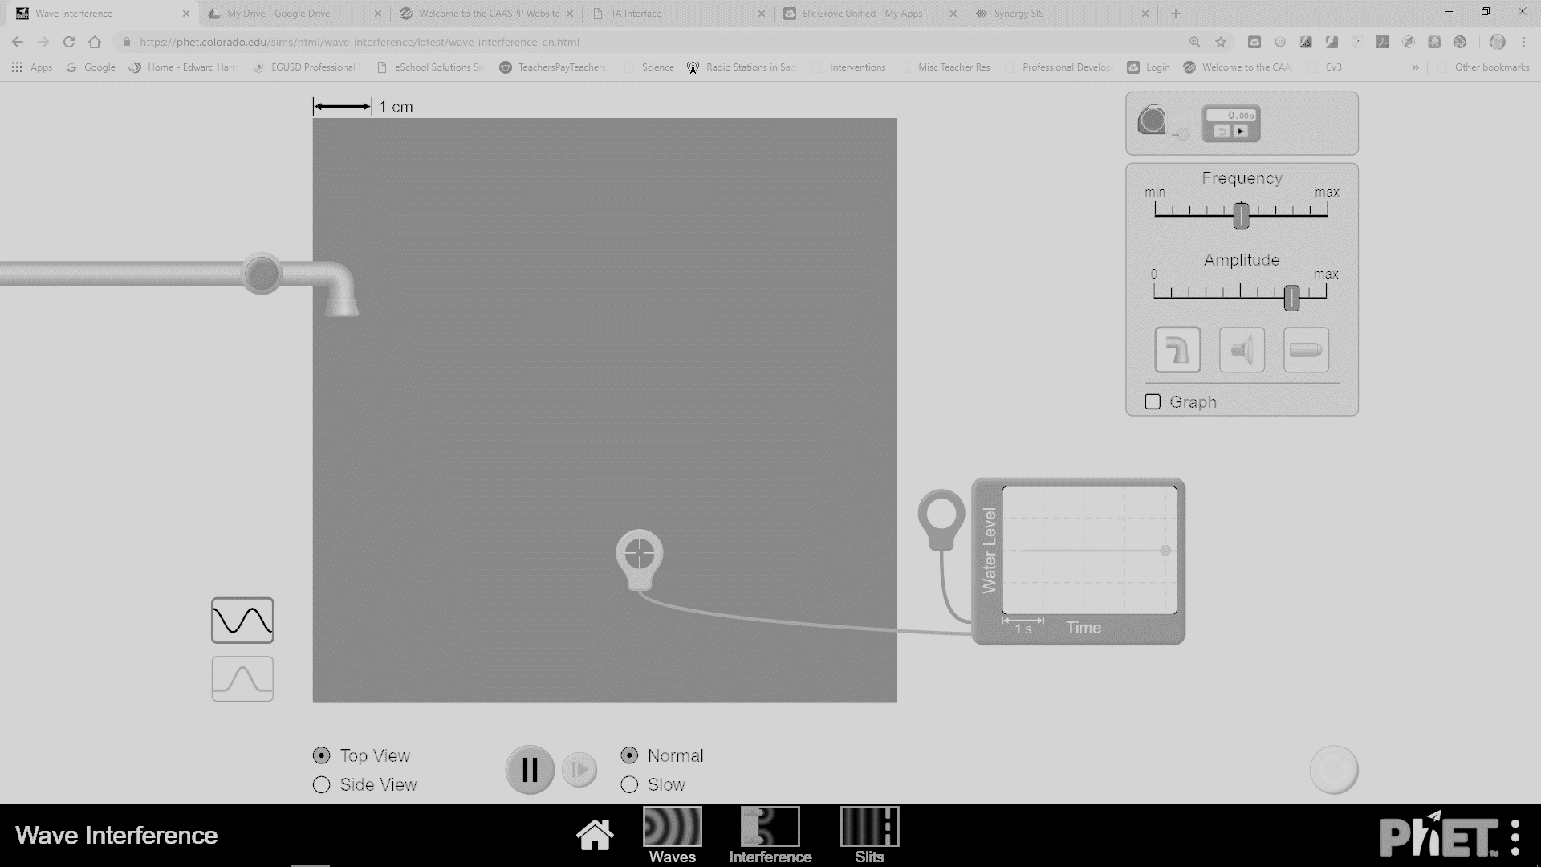

7. Using and viewing the wave meter. Increase and decrease amplitude, what happens to the waves on the meter? Draw what you see.

8. Using and viewing the wave meter. Increase and decrease frequency, what happens to the waves on the meter? Draw what you see.

**Use the pulse option (bottom left of screen, click on the one wave) AND change the view of the water to a side view.**

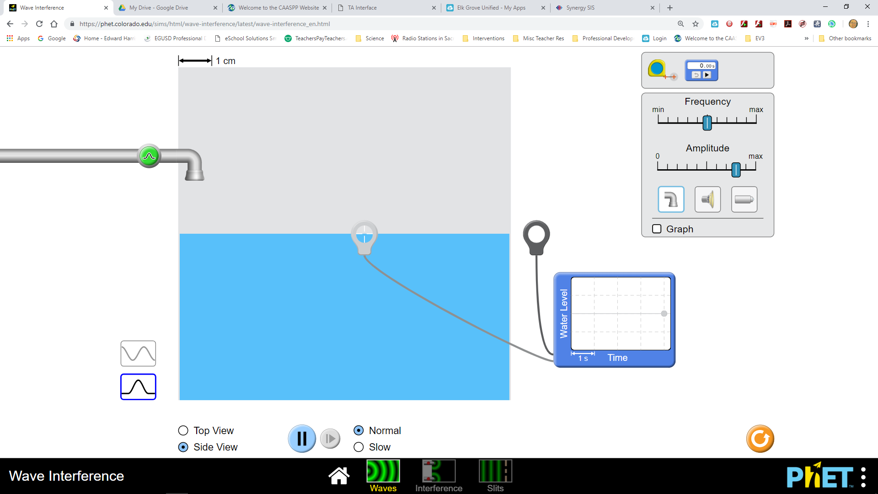

9. You will have to press the green button each time to generate a wave. Manipulate the amplitude and frequency for a few minutes and describe your experience.

**Go back to Waves Intro and click on Sound, be sure to also attach your wave meter. Click on “both” so you can view the waves and particles.**

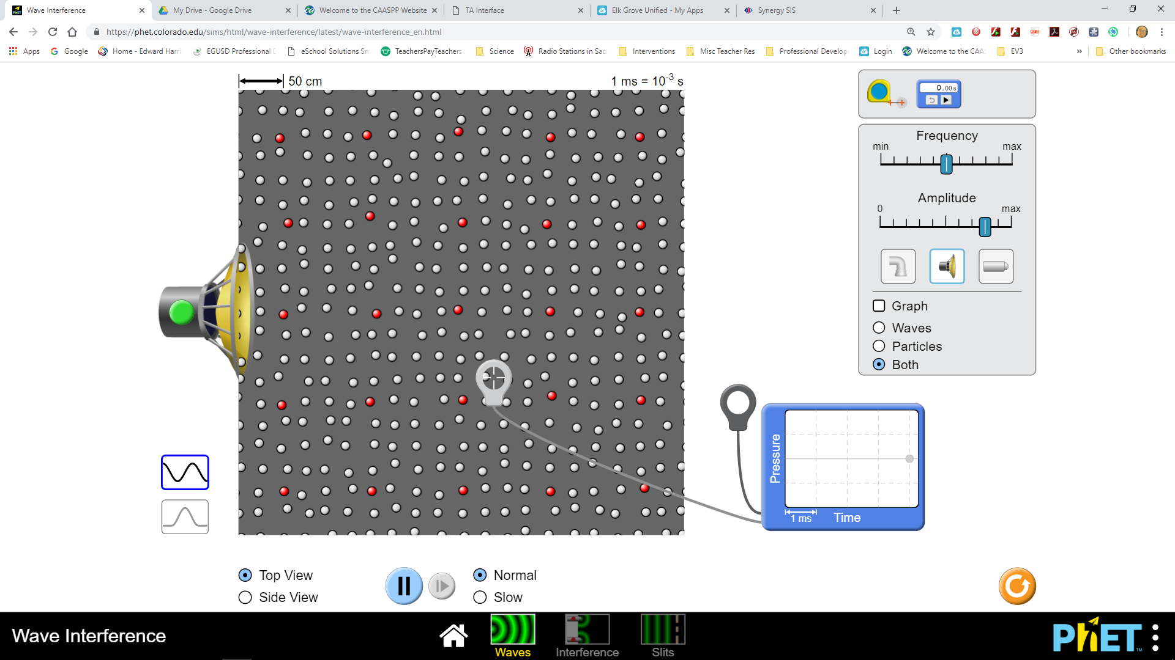

10. Explore the sound simulation for several minutes. Be sure to manipulate the amplitude and frequency. Describe your experience and be sure to describe what you notice about the particles?

**Go back to Waves Intro and click on Light, be sure to also attach your wave meter. Also, click on “screen.”** 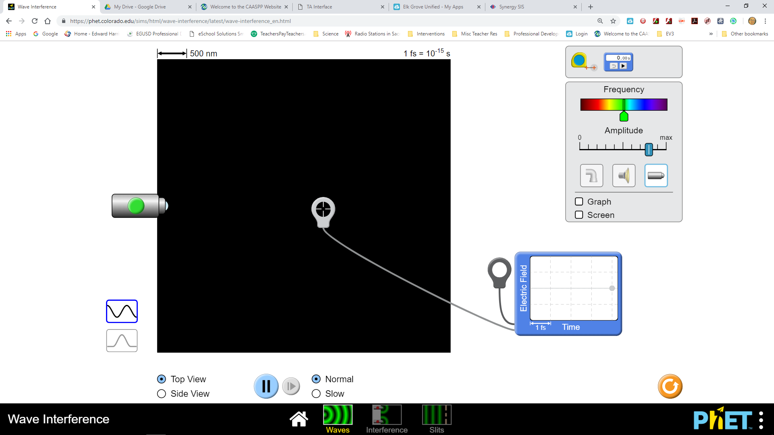

11. Explore the light simulation for several minutes. Be sure to change the colors. What do you notice about changing the colors?

12. View the colors again and pay attention to their wavelengths. Compare and contrast the wavelengths in red light, green light, and violet light.

13. Why does the screen turn the color of the light being emitted?

**Go back to Waves Intro and Sound. Click on “graph” and explore the simulation.**

14. What is being graphed with sound waves (look at the labels on the x and y-axis)?

15. Compare the waves at the start of the graph to the end of the graph. What happens to the waves on the graph over time?

**Go back to Waves Intro and Light. Click on the “graph” and explore the simulation.**

16. What is being graphed with light waves (look at the labels on the x and y-axis)?

17. Compare the waves at the start of the graph to the end of the graph. What happens to the waves on the graph over time?